Unit I - Fourier series

Fourier series in an interval of length 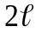
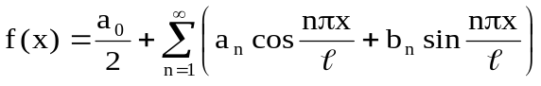

Fourier series of f(x) in 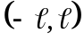
Fourier series of f(x) in 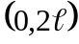

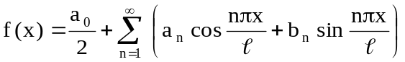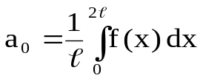
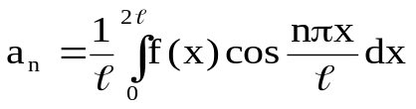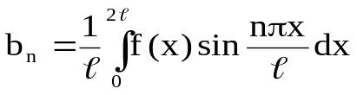

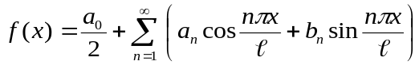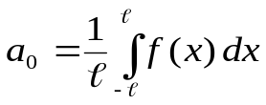
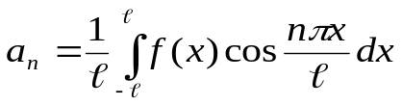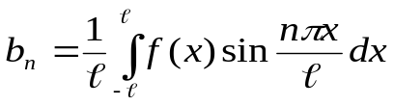

Even Function Odd Function
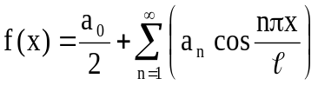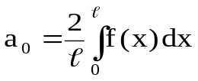

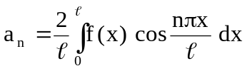
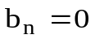
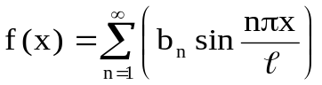

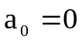
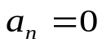
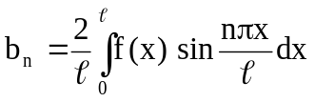

Convergence of Fourier Series:

- At a continuous point x = a, Fourier series converges to f(a)
- At end point c or c+2l in (c, c+2l), Fourier series converges to 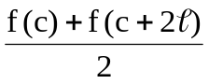
- At a discontinuous point x = a, Fourier series converges to 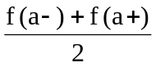

Fourier series in the Interval of length 2π
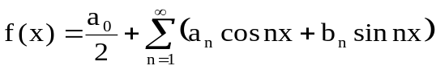

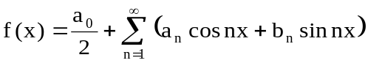
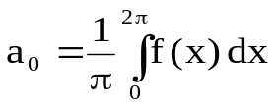
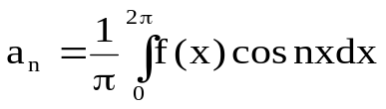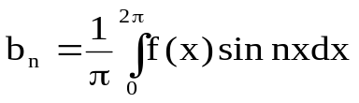

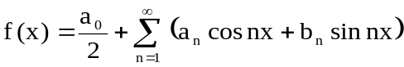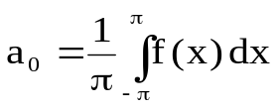
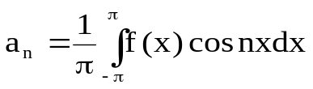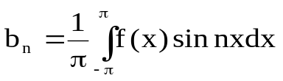

Fourier Series of f(x) in (0,2)
Fourier Series of f(x) in (-,)

Even Function Odd Function

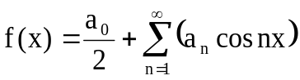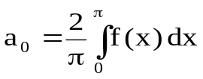
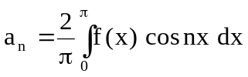
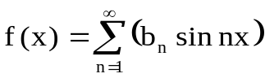
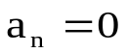
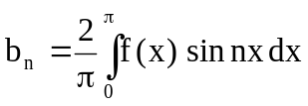

Half Range Fourier series

Fourier Cosine Series Fourier Sine Series
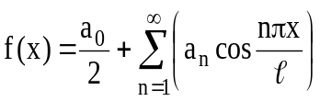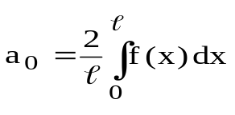
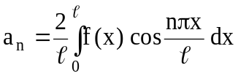

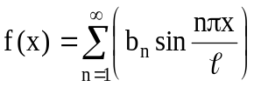
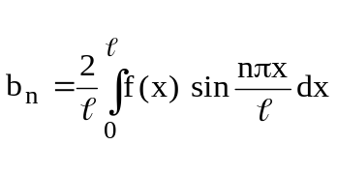

Convergence of Fourier Cosine series:

- At a continuous point x = a, Fourier cosine series converges to f(a).
- At end point 0 in(0,l), Fourier cosine series converges to f(0+)
- At end point l in(0,l), Fourier cosine series converges to f(l-)

Convergence of Fourier Sine series:

- At a continuous point x = a, Fourier Sine series converges to f(a).
- At both end points Fourier Sine series converges to 0.

Harmonic Analysis:
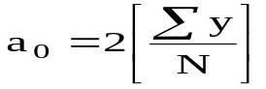, 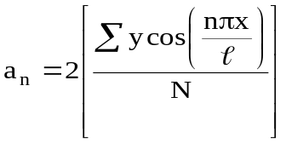, 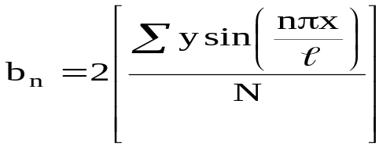

Parseval’s Theorem:

If 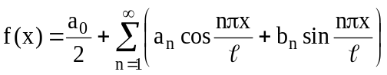 is the Fourier series of f(x) in (c, c+2l),
Then 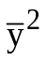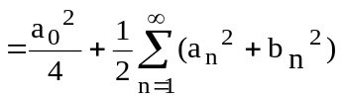 (or) 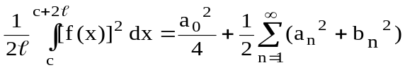

Root Mean Square Value:

is the effective value (or) Root Mean square (RMS) value of the function y = f(x), which is given by
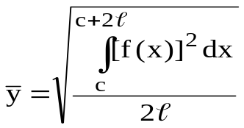

Some Important Results:

- Sin nπ =0 for all integer values of n
- Cos nπ= (–1)^{n} for all integer values of n
- Cos2nπ=1 for all integer values of n
- Sin2nπ = 0 for all integer values of n
- If f( –x ) = f( x ) then f(x) is even and If f( –x ) = – f( x ) then f( x ) is odd.
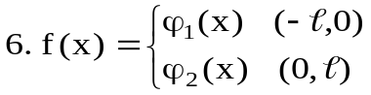is even if either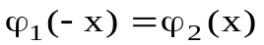or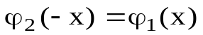
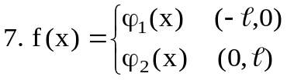is odd if either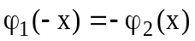or 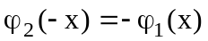
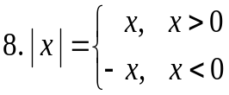
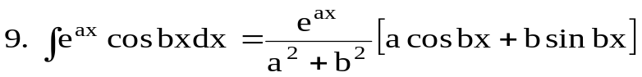
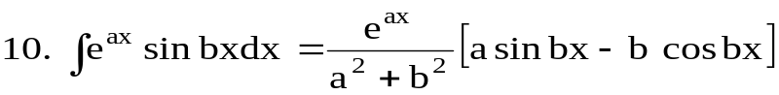
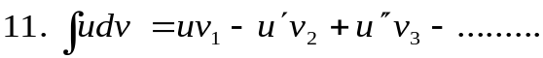Where

